

# FACULTY OF INFORMATION TECHNOLOGY BACHELOR OF BUSINESS INFORMATION TECHNOLOGY CAT 1 BBT 3104: ADVANCED DATABASE SYSTEMS

## DATE: 13th May 2020 Duration: 1 Week

## INSTRUCTIONS

1. This assessment is intended to improve your learning by measuring your progress towards the learning outcomes (page 5 of 18 on the course outline) and using this measurement as feedback on the topics or concepts that you may have misunderstood.
2. Success in the assessment will be achieved through decisive demonstrations of understanding and **NOT** through the memorization and reproduction of disconnected facts.
3. The assessment consists of **SIX** compulsory questions and **ONE** optional bonus question.
4. Submission of your work will be via the TurnItIn link provided on eLearning only (**NOT** through email). The deadline for submitting your work is Wednesday 20th May 2020 at 4 pm.

## COMPULSORY QUESTIONS *(50 marks)*

SUPPOSE that you and some of your classmates come together to form your own income generating business after noticing the damage that the covid-19 pandemic has had on the economy and subsequently on the ability of businesses to hire new employees. After successfully going through all the legal requirements to set up a business, you proceed to market your services which pertain providing data solutions. One of your first clients, Zambikes Limited, approaches you after realizing the importance of accurate data provided to the right employees at the right time to make the right decisions. Watch the case study video provided via [this link](https://www.youtube.com/watch?v=cm-PhEliyIQ) ( <https://www.youtube.com/watch?v=cm-PhEliyIQ>) to understand what your client does and how they do it.

1. You realize that it is important for you and your colleagues to have the same understanding of what your client does, how they do it, and why they do it. Create a graphical representation of your client’s business process showing how the processes in different departments interact with each other where possible. State any assumptions you have made in cases where you do not have the full information about a department’s business process. *(10 marks)*

**Answer**

Zambikes Limited has different processes namely:-

1. procurement process which involves ordering goods form suppliers
2. Production process
3. Inventory process and management
4. Sales Process which involves purchase orders from customers

The assumption made :

1. that zambikes have an established relationship with their international and local suppliers
2. That all steel bikes ,zamcart and zambulance use the same procedure in their production.
3. All the bamboo frames passed the job cart testing
4. All purchase orders whether local or international go through the same process

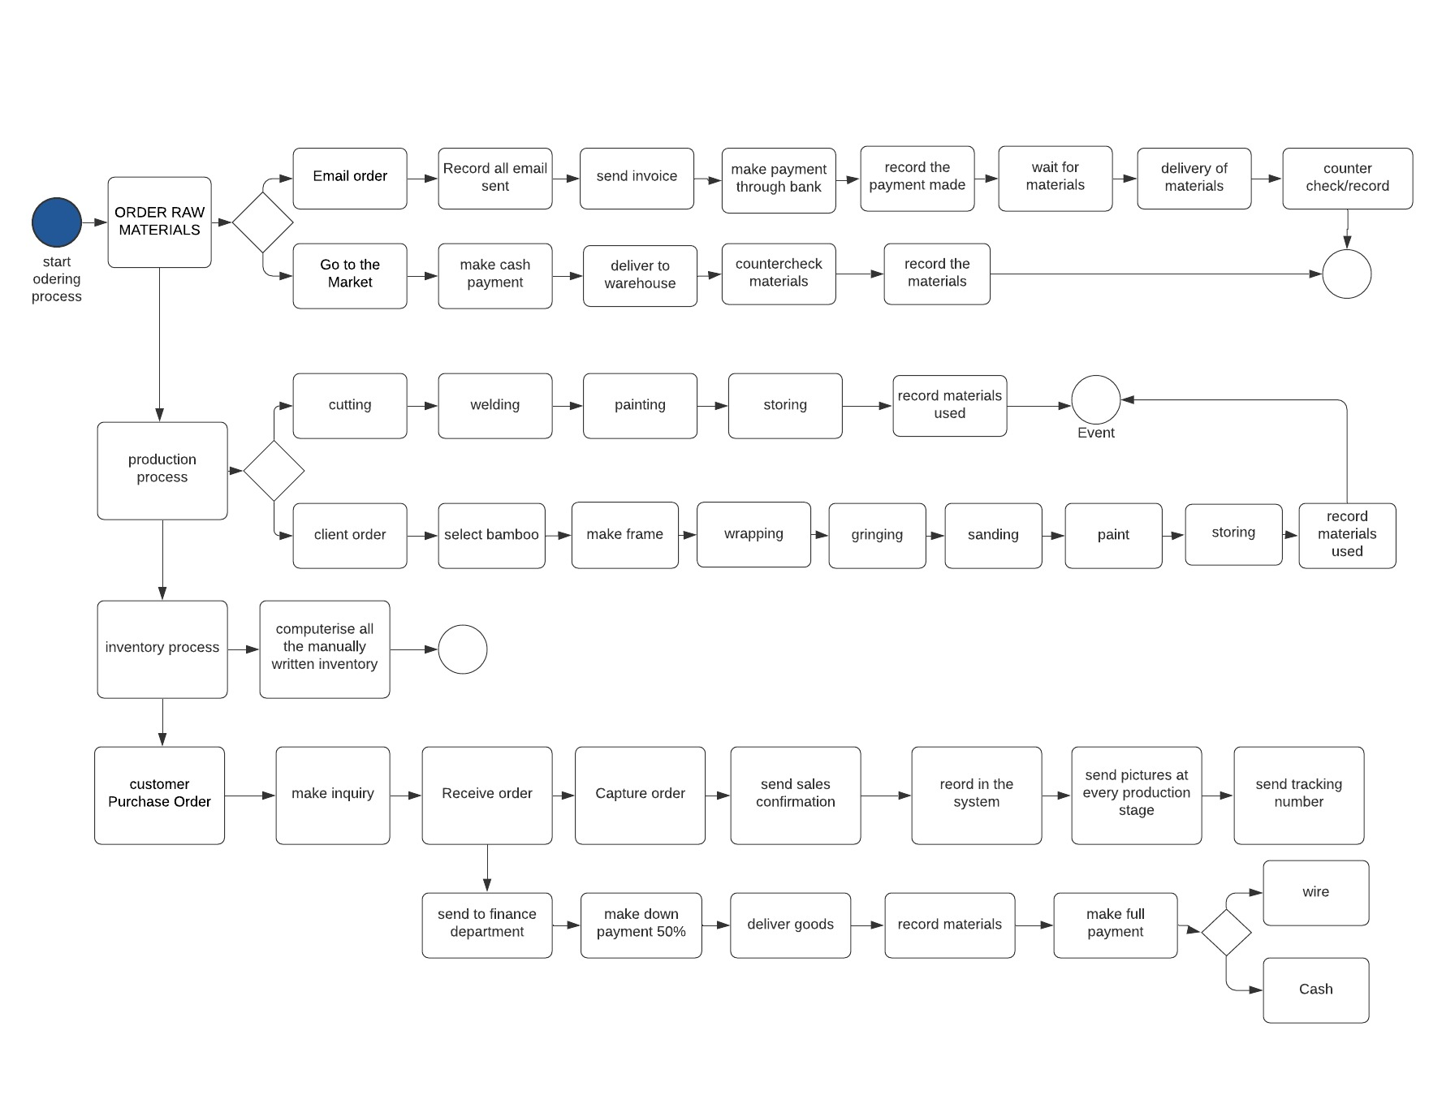

**Figure 1The business process of zambikes**

1. Based on your understanding of what your client does, how they do it, and why they do it, create a graphical representation showing how data flows through your client’s business in form of a Data Flow Diagram (DFD level 0 and level 1). *(10 marks)*

***Answer***

i.Context (level 0 diagram)

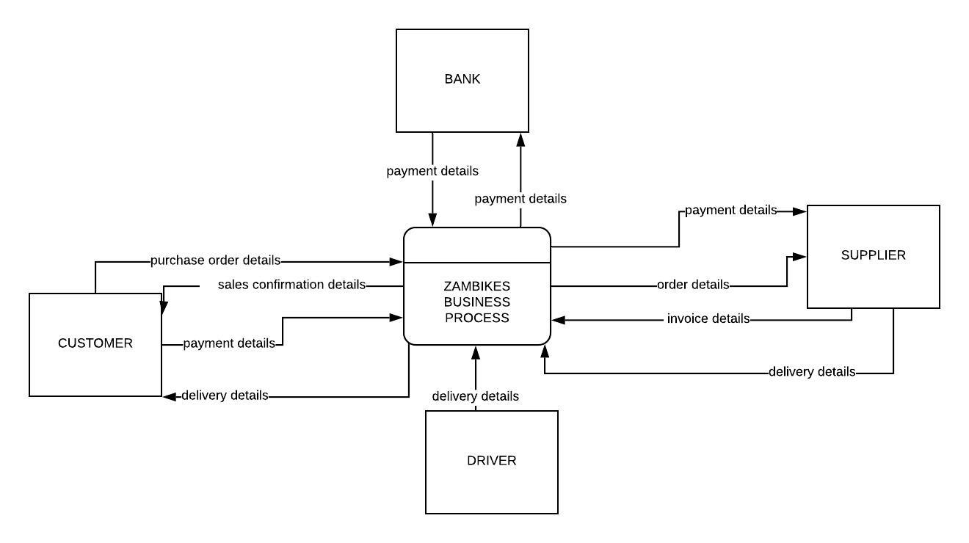

LEVEL 1 DIAGRAM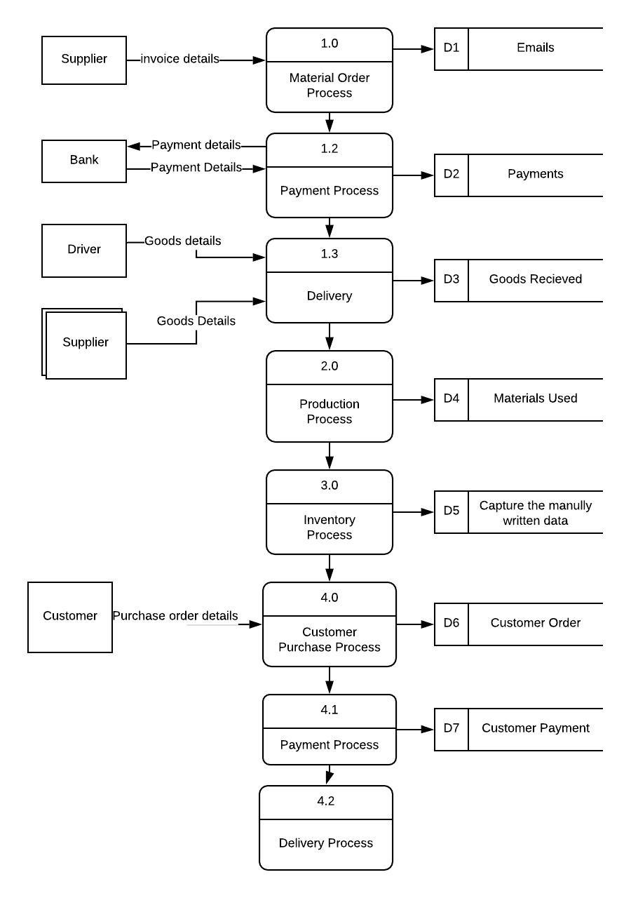

1. List and briefly explain all the information that can help your client to improve its operations if they were to receive it in form of Business Intelligence (BI) or analytics reports on a dashboard. *(5 mark)*

***Answer***

In any organization it is important to know trends in the business in order to make decisions and predict future endeavors. This is made possible by the Business Intelligence reports generated on the dashboard. For example:

1. Number of Sales made -A pie chart depicting the sales of each product that is the amount of zambikes, zambulance’s and zamcarts sold say per month this will be important to know what products are selling and what are not hence certain decisions made. These decisions may include promotion of these products or giving offers to make them more attractive to customers.
2. Number of employees - A bar graph showing the amount of manpower/employees is important because they can easily keep track of the amount of people required to make different products manage their salaries and award bonuses or commissions if earned and also in times of power outage the temporary manpower included might be easily traced and payed accordingly.
3. Number of parts used per product- A table tabulated with the amount of materials used per day. Is very useful in that the amount of input and output given can be used to calculate the Revenue made in that month. Therefore, they can determine the amount of wastage and how to minimize it. This is also going to be easier to tabulate since they have the challenge of tired employees who guess or forget to record the parts used in a day will therefore find it easy to just compute the numbers.
4. Quantity and Quality of products -A comparative bar graph may be drawn to compare the amount of products produced per month and also determine reasons as to why the output was low. This also gives them an opportunity to know whether to add more machines or rather add more manpower.
5. A mount of Revenue/Returns made-A simple bar graph can be created from the information gathered from the sales made and the amount of goods received and the expenses encountered to compute the revenue and see a trend over the years
6. Customer satisfaction and feedback-This information is important because Zambikes is a customer oriented organization as seen by sending pictures of the bikes at different stages and tracking numbers of the delivery. This therefore can be in form of a pie chart depicting the percentages of customer satisfaction.
7. Supplied goods and their prices –A bar graph showing the amount of materials purchased and the date purchased and the price of the goods is beneficial since it aids in the calculation of the revenue and also the status of a supplier is important to know the ones actively involved and those who the company changed their loyalty from hence giving a sense of comparison for the quality of goods received.
8. Based on your knowledge of what your client requires from the database in form of BI or analytics reports, work backwards to specify what the database is required to store so that your client can retrieve these reports. These requirements should be divided into 3 sections (capabilities,

conditions, and constraints) such that each condition is traceable to a capability and each constraint is also traceable to a capability. *(10 marks)*

ANSWER

|  |  |  |
| --- | --- | --- |
| SYSTEM CAPABILITIES | SYSTEM CONDITIONS | SYSTEM CONSTRAINTS |
| **A.) SALES**  **The database should be able to store the following:-**  1.Sales ID  2.Product ID  3.Product name  4.Product Quantity  5.Amount made from the sales (Amount made)  6.Date Sold. | A.1 The Sales Id is automatically generated from the first day a product is sold and it is registered in the system  A.2 Each product made has an individual serial number. The Product Id here is borrowed from the Product Table  A.3The product name is one of the products produced by Zambikes  A.4The product quantity of items of each product sold  A.5 The amount made from sales is the total sum of money collected from the sales made  A.6The Date Sold is the day that will be Time zone converted to East African time | A.1.1The data contained in the SalesID field must conform to the intrarelational, static, VARCHAR (56) domain constraint  A.2.2. The data contained in the Product Id name field must conform to the intrarelational, static, VARCHAR (56) domain constraint  A.3.3The data contained in the product’s name field must conform to the intrarelational, static, VARCHAR domain constraint  A.4.4The data contained in the Product quantity field must conform to the intrarelational, static, INT domain constraint  A.5.5The data contained in the Amount made field must conform to the interrelational, static, INT domain constraint  A.6.6The data contained in the Date Sold field must conform to the intrarelational, static, DATE domain constraint |
| **B.) EMPLOYEE DETAILS**   1. Employee ID 2. Employee name 3. Employee contacts 4. Department 5. 4.Employee working hours 6. Gross Salary 7. Employee Status | B.1 An Employee ID shall be provided by the company. Each employee shall be given a unique Id that coincides with the department they are in  B.2 The Employees name shall contain the first name, the middle name, and the last name only.  B.3 The Employee contacts shall include the employee’s national identification number, email and telephone number(s)  B.4The department id the section in which the employee works under  B.5The gross salary is the amount the employee makes including bonuses and commissions if any  B.7The employee status is to show that the employee is still working with the organization or whether they left. | B.1.1The data contained in theEmployee ID field must conform to the intrarelational, static, VARCHAR domain constraint  B.2.2The data contained in the Employes’s name field must conform to the intrarelational, static, VARCHAR domain constraint  B.3.3The data contained in the Employee contacts the data contained in the field must conform to the intrarelational, static, VARCHAR domain constraint and be in the form of a valid email address  B.4.4The data contained in the department field must conform to the intrarelational, static, INT domain constraint  B.5.5The data contained in gross salary field must conform to the intrarelational, static, VARCHAR domain constraint  B.6.6The data contained in the Employee status field must conform to the intrarelational, static, Boolean domain constraint  B.7.7The data contained in the Employee working hours field must conform to the intrarelational, static, INT domain constraint |
| **C.) PRODUCTION**  1.) Product Id  2.Product Name  3.Product Description  4.Product manufacture Date  5.Amount of Defects  6.Working Hours  7.Goods Received | C.1 The ProductId is a unique identifier that is automatically generated from the first day a product is sold and it is registered in the system  C.2 Each product made has an individual serial number. Which shall be recorded in the system  C.3The product Description is the category of the products produced by this organization only  C.4The Product Manufacture Date is the date in which the parts or full product was assembled only as indicated by the workers.  C.5 Amount of Defects are the amount of products that are of poor quality of are not up to expectations and had to be thrown away or modified  C.6 Working Hours are the number of hours the employees took to develop a certain product  C.7.Goods Received are the materials used in the developments of these products as ordered and received from the suppliers | C.1.1The data contained in the ProductID field must conform to the intrarelational, static, VARCHAR domain constraint  C.2.2The data contained in the Product name field must conform to the intrarelational, static, VARCHAR domain constraint  C.3.3The data contained in the Product description field must conform to the intrarelational, static, VARCHAR domain constraint  C.4.4The data contained in the product manufacture date field must conform to the intrarelational, static, VARCHAR domain constraint  C.5.5The data contained in the Amount of defects field must conform to the intrarelational, static, VARCHAR domain constraint  C.6.6The data contained in Working hours field must conform to the intrarelational, static, VARCHAR domain constraint  C.7.7The data contained in the Goods received field must conform to the intrarelational, static, VARCHAR domain constraint |
| **D.) CUSTOMER**  1.Customer ID  2.Customer name  3.Product Name  4. Products Purchased  5.Amount of purchases  6.Payment method  7.Date of Purchase  8.Customer Remarks  9.Customer contacts | D.1 A Customer identification number shall be a national identity number only 1 national identity number shall be recorded per purchase.  D.2 The Customer name shall contain the first name, the middle name, and the last name only.  D.3. The product name is one of the products produced by Zambikes as displayed for the customer to see  D.4Products Purchased are the names of the products purchased by the customers only  D.5Amount of purchases are the amount of each product purchased by the customer only  D.6 Payment method Is the method used to pay for the goods purchased.  D.7Date of Purchase is the date the customer purchased a product the day that will be Time zone converted to East African time  D.8Cusomer remarks is the feedback pf how satisfied they are with a particular product any any other suggestion they may have  D.9The client’s contacts shall include the client’s email and telephone number(s) | D.1.1The national identity number is will be in the form of an intrarelational, static, composite key constraint to form the primary key. The national identity number should have an INT domain constraint and the company PIN should have a VARCHAR domain constrain  D.2.2The data contained in the customers’s name field must conform to the intrarelational, static, VARCHAR domain constraint  D.3.3The data contained in the Product name field must conform to the intrarelational, static, VARCHAR domain constraint  D.4.4The data contained in the Products purchased field must conform to the intrarelational, static, VARCHAR domain constraint  D.5.5The data contained in the Amounts of purchases field must conform to the intrarelational, static, VARCHAR domain constraint  D.6.6The data contained in the Payment method field must conform to the intrarelational, static, VARCHAR domain constraint  D.7.7The data contained in the Date of purchase field must conform to the intrarelational, static, VARCHAR domain constraint  D.8.8The data contained in the customer remarks field must conform to the intrarelational, static, VARCHAR domain constraint  D.9.9The data contained in the Customers’s email field must conform to the intrarelational, static, VARCHAR domain constraint and be in the form of a valid email address |
| **E.) Supplier**  1.Supplier Id  2.Supplier Name  3.Goods Ordered  4.Materials Received  5.Invoice for each good  6.Amount Budgeted  7.Supplier Status  8.Date of Delivery  9.Supplier Contacts | E.1Supplier Id is the unique Identifier company PIN of the respective supplier.  E.2 The Supplier’s name shall contain the company name only.  E.3.Goods Ordered are the materials sort after to help in the assembly of their products  E.4 Materials Received are the materials to be used in the developments of products  E.5 Invoice for each good is the sum of money that needs to be payed for the purchase of these materials  E.6The amount budgeted is the sum of money that was estimated for the materials to be used only  E.7The Supplier status is to show that the employee is still working with the organization or whether they left.  E.8Date of Delivery is the date the supplier or the company went out to retrieve purchased materials or the supplier delivered the materials the day that will be Time zone converted to East African time  E.9The client’s contacts shall include the client’s email and telephone number(s) | E.1.1 The company PIN constraint. This will be in the form of an intrarelational, static, composite key constraint to form the primary key and the PIN should have a VARCHAR domain constrain  E.2.2The data contained in the Suppliers’s name field must conform to the intrarelational, static, VARCHAR domain constraint  E.3.3The data contained in the Goods orderd field must conform to the intrarelational, static, VARCHAR domain constraint  E.4.4The data contained in the Materials Received field must conform to the intrarelational, static, VARCHAR domain constraint  E.5.5The data contained in the Invoice for each good field must conform to the intrarelational, static, INT domain constraint  E.6.6The data contained in the Amount Budgeted field must conform to the intrarelational, static, INT domain constraint  E.7.7The data contained in the supplier status field must conform to the intrarelational, static, BOOLEAN domain constraint  E.8.8The data contained in the Date of delivery field must conform to the intrarelational, static, VARCHAR domain constraint  E.9.9The data contained in the client’s email field must conform to the intrarelational, static, VARCHAR domain constraint and be in the form of a valid email address |

1. Create a design representing the proposed data solution. This design should be in the form of an Enhanced Entity Relationship Diagram. *(10 marks)* 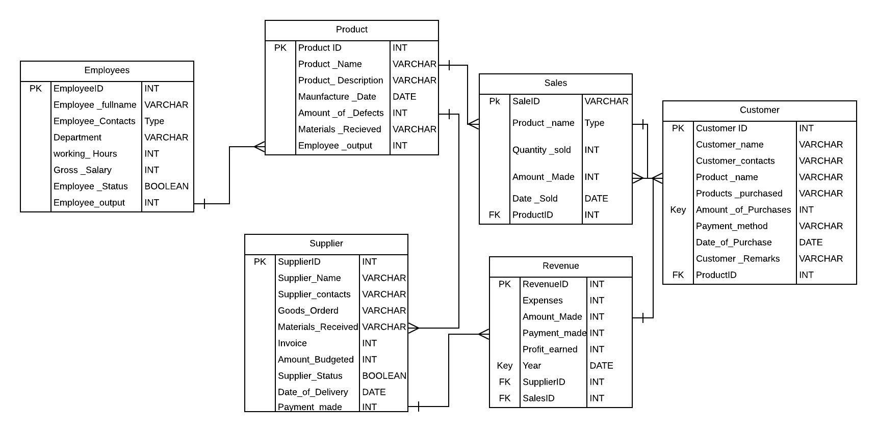
2. Create a design of the proposed system architecture for the data solution. This system architecture design should have an approximate price of each component and a justification as to why it is the ideal architecture for your client. This will help your client to create an appropriate budget for the data solution that your company is proposing before you begin developing the solution. Assume that your client has only 2 personal computers and 1 access point for Internet services as its IT assets and requires capital expenditure (CAPEX) to purchase new IT assets. *(5 marks)*

*For example, if you propose a 3-tier client-server architecture, you need to specify the approximate price for purchasing the computers (tier-1) and the servers (tiers 2 and 3). You also need to justify why you propose the architecture, perhaps tier 2 (the application server) is necessary for generating the BI/analytics reports from the database server.*

A 3 tier network is DBMS architecture contains an Application layer between the user and the DBMS, which is responsible for communicating the user's request to the DBMS system and send the response from the DBMS to the user.

The application layer(business logic layer) also processes functional logic, constraint, and rules before passing data to the user or down to the DBMS

Three tier architecture is the most popular DBMS architecture.

**The goal of Three-teir architecture is:**

* To separate the user applications and physical database
* Proposed to support DBMS characteristics
* Program-data independence
* Support of multiple views of the data

The **SAP** stands for Systems Applications and Products in Data Processing. SAP, by definition, is also the name of the ERP (Enterprise Resource Planning)which is an important aspect of any Business Intelligence system in order to automate the availability of products for the customers to buy.

CapEx= ΔPP&E+Current Depreciation

**where:** CapEx=Capital expenditures

ΔPP&E=Change in property, plant, and equipment​

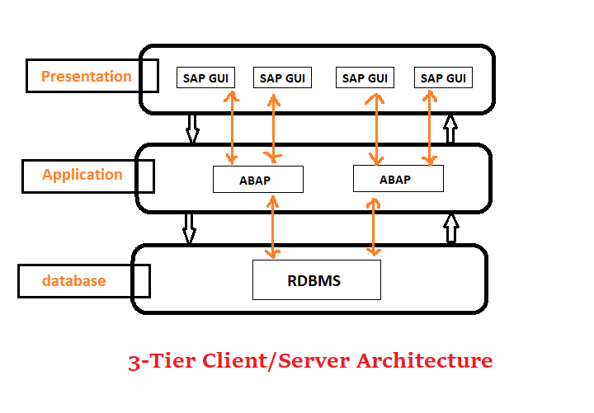

Using the above concept below is the proposed system architecture and the budget of each attribute.

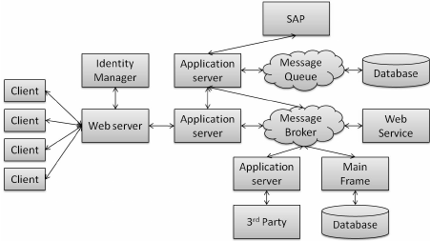

BUDGET

1. )3PC’S-HP 200 G3 All-In-One - Core i3- 4 GB - 1000 GB/1 TB - 21.5" LED **KSh 60,000 each**

Top of Form

1. )10 Tablets-Samsung Galaxy Tab S6 Lite, 10.4"  -4GB RAM - 64GB ROM - Wi-Fi - Android 10 -Oxford Gray **KSh 45,899**
2. MainframeInstant recovery, encryption capabilities and cloud native developments certainly do come with a significant price tag. Each mainframe is custom built and costs anywhere from **$250,000—KSH 25,000,000**